Consultation Questionnaire Exemptions 18(b) of RoHS Annex III
Table 1 shows the current wording of the exemptions on Annex III of the RoHS Directive.
Table 1: Currently valid wordings of exemption III-18(b)
No. | Current exemption wording | Current scope and dates of applicability
III-18(b) | Lead as activator in the fluorescent powder (1 % lead by weight or less) of discharge lamps when used as sun tanning lamps containing phosphors such as BSP (BaSi2O5:Pb) | Applies to categories 1 to 11.  Expires on  - 21 July 2021 for categories 1-7 and 10.  - 21 July 2021 for category 8 other than in vitro diagnostic medical devices and category 9 other than industrial monitoring and control instruments.  - 21 July 2023 for category 8 in vitro diagnostic medical devices.  - 21 July 2024 for category 9 industrial monitoring and control instruments, and for category 11.

ACRONYMS AND DEFINITIONS
COM European Commission
EEE Electrical and electronic equipment
IMCI Industrial monitoring and control instruments

Background and objectives of this review
Bio Innovation Service, UNITAR-SCYCLE and Fraunhofer IZM have been appointed by the European Commission for the evaluation of applications for new exemptions and the renewal of exemptions currently listed in Annexes III and IV of the RoHS Directive 2011/65/EU.
LightingEurope requested the renewal of exemption 18(b) with its current wording for the maximum validity periods for cat. 11. The European Sunlight Association and NARVA Lichtquellen GmbH & Co support LightingEurope’s request. The applicant was requested to respond to a clarification questionnaire prior to this stakeholder consultation to provide missing information. This questionnaire, along with the exemption application, and – if submitted - supporting evidence from other stakeholders, are accessible on the consultation web page.
The stakeholder consultation is part of the review process for the exemption request at hand. It addresses third parties – not the applicants – to provide and to evaluate information and evidence according to the criteria listed in Art. 5(1)(a) of Directive 2011/65/EU.
Exemption 18(b) was reviewed by Baron et al. (2022) resulting in the below recommendation.
Table 2: Proposed renewal of exemptions 18(b) in the last review in 2022
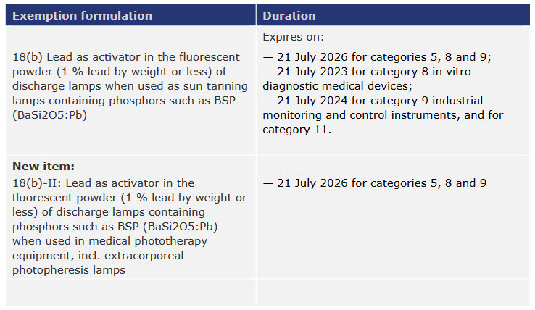
Source: Baron et al. (2022)
The European Commission (COM) have not yet officially published their decision as to the adoption of the above recommendation. The COM wishes the consultants to assess in this current review round whether there are any substantial reasons in line with Art. 5(1)(a) against the adoption of the above recommendation for EEE of categories 8, 9 and 11 (RoHS Annex I). This implies that the consultants will assess whether the validities of exemptions whose renewal is requested for cat. 8, 9 or 11 may exceed the validities recommended in the previous review (Table 2). Table 3 reflects the potential scope and wording if the exemptions are renewed for cat. 11.
Table 3: Renewal of exemption 18(b) for cat. 11
No. | Exemption | Scope and dates of applicability
III-18(b) | Lead as activator in the fluorescent powder (1 % lead by weight or less) of discharge lamps when used as sun tanning lamps containing phosphors such as BSP (BaSi2O5:Pb) | Applies to categories 5, 8, 9 and 11.  Expires on  - 21 July 2023 for category 8 in-vitro diagnostic medical devices.  - 21 July 2024 for category 9 industrial monitoring and control instruments.  - 21 July (2024 + A) for category 11  - 21 July 2026 for categories 5, 8 other than in-vitro diagnostic medical devices and 9 other than industrial monitoring and control instruments;
A can range between 0 and 5 years.
To contribute to this stakeholder consultation, please answer the below questions until 11 December 2023.

Questions
- In the clarification questionnaire LightingEurope states that indoor tanning appliances could fall under cat. 5 as well as cat. 11. Furthermore, according to LightingEurope “It is not completely clear how to classify suntanning equipment and consequently we see that the classification can differ. Manufacturers are not sure whether to exclusively focus on the suntanning lamps and assign them to Category 5 (lighting equipment) or whether the focus should be on the equipment itself (e.g., sunbeds) which includes lighting functionalities.”.

  - In case you do not agree to LightingEurope’s above conclusions, please support your views with detailed technical argumentation / evidence in line with the criteria in Art. 5(1)(a). Under which category do the lamps as well as the devices (suntanning equipment) fall instead?

  - Do you agree that that exemption is required for cat. 11 for another five years until 2029? Please provide arguments and evidence for your opinion.

  - Are you aware of lead-free substitutes that are used in applications in the scope of exemption 18(b)?

  - Are you aware of research for possibilties to substitute or eliminate use of lead in suntanning appliances? If so provide details and a roadmap showing the status and the next steps of the research.

- Baron et al. recommend the following in their review in 2022: “It should be envisaged to review the exemptions 18(b) and the new item 18(b)-II in parallel in the future. In case, a substitute was found for one of both uses of lead, it is highly probable that this substitute could be implemented in both applications. Thus, it is recommended to align all named categories in terms of the validity period. Also, this will be more pragmatic for market surveillance and will with time lower the administrative burden of stakeholders and the European Commission with regards to renewed exemption requests for the coexisting exemptions.” This would result in an extension of the exemption for category 11 from the current expiry in 2024 to to 2026 for the above-mentioned reasons even if the requested exemption renewal is not recommended.
  - In the clarification questionnaire LightingEurope was asked why cat.11 should not be phased out in 2026 as well. They argued that applying in this timeframe (18 months before the exemption expires in 2026) would not allow time for new developments in the industry to be reported in the exemption application.
In your opinion, is this a sufficient reason against alignment?

  - In case you do not agree with the recommendation of Baron et al. please support your views with detailed argumentation / evidence in line with the criteria in Art. 5(1)(a).

- LightingEurope provided a socioeconomic analysis related to sun tanning lamps containing lead as an activator. The document is available online in the consultation folder for this exemption.
Do you agree with the underlying data and conclusions?

- Is there any additional information which you would like to provide?

Please note that answers to these questions can be published on the stakeholder consultation website and in the review report. If your answers contain confidential information, please provide a version that can be made public along with a confidential version, in which proprietary information is clearly marked.
Please do not forget to provide your contact details (Name, Organisation, e-mail and phone number) so that the project team can contact you in case there are questions concerning your contribution.
It would be helpful for the review process if you could kindly provide the information in formats that allow copying text, figures and tables to be included in the review report.

It is implemented through the specific contract 070201/2020/832829/ENV.B.3 under the Framework contract ENV.B.3/FRA/2019/0017
Consultation web page: https://rohs.biois.eu/requests2.html
Directive 2011/65/EU (RoHS) available at http://eur-lex.europa.eu/LexUriServ/LexUriServ.do?uri=CELEX:32011L0065:EN:NOT
C.f. Öko-Institut, https://rohs.exemptions.oeko.info/fileadmin/user_upload/RoHS_Pack_24/RoHS_Pack-24_final_16022022.pdf

